Exploratory Data Analysis of Income, Employment and Education

Project Report

Dataset: UCI Adult Income (1994 U.S. Census)

Submitted by: Suvaibathul Aslamiya Up

Course: AI-Driven Data Analytics

Tools: Python | Google Colab | NumPy | Pandas

Matplotlib | Seaborn | Plotly

1. Abstract
This project presents an Exploratory Data Analysis (EDA) of the UCI Adult Income dataset, which is based on the 1994 U.S. Census database. The aim is to understand how educational, employment-related and demographic factors are associated with whether a person earns more than 50K per year. Python libraries were used for cleaning, analysis and visualization. The analysis shows that about 75.91% of individuals earn <=50K and 24.09% earn >50K. Higher education levels (Bachelors, Masters, Doctorate, Prof-school) are more strongly represented in the >50K group, and the >50K group is slightly older and works slightly longer hours on average. Most numerical variables show only weak linear correlations. The findings describe associations and do not prove that any one factor causes higher income.

2. Introduction
Income is influenced by many factors such as education, type of employment, working hours, age and personal background. Exploratory Data Analysis is the process of examining a dataset using summary statistics and visualizations to discover patterns, spot anomalies and form ideas before any modelling is done.
This project applies EDA to the Adult Income dataset to study how education, employment and demographic variables relate to the income category (<=50K or >50K). The work follows a clear flow: loading the data, cleaning and preprocessing, checking outliers, univariate, bivariate and multivariate analysis, statistical analysis, visualization and finally insights.

3. Project Objectives
- To analyze the relationship between education and income levels.
- To examine how employment-related factors such as workclass, occupation and working hours are associated with income.
- To study the influence of demographic factors such as age, marital status, sex and race on income categories.
- To identify important patterns and relationships between education, employment, demographics and income.
- To clean and preprocess the data by handling missing values, removing duplicate records, and checking invalid values, inconsistent values and outliers, so that the analysis is reliable.
- To summarize the key findings using statistical analysis and data visualizations.

4. Dataset Description
Attribute | Value
Source | UCI Machine Learning Repository
Original source | 1994 U.S. Census database
Records | 32,561 individuals (32,537 after removing duplicates)
Features | 14 input features
Total columns | 15 (including target)
Target variable | Income (<=50K / >50K)
Data types | 6 numerical and 9 categorical columns

The columns are grouped as follows:
- Demographic: age, race, sex, native_country
- Employment: workclass, occupation, hours_per_week
- Education: education, education_num
- Personal: marital_status, relationship
- Financial: fnlwgt, capital_gain, capital_loss
- Target: income

5. Tools and Technologies Used
- Python (Google Colab): programming language and notebook environment used for the whole project.
- Pandas: loading, cleaning, organizing and analyzing the data.
- NumPy: numerical operations and calculations.
- Matplotlib: creating charts and graphs.
- Plotly: creating the interactive donut chart of income distribution.
- Seaborn: statistical visualizations such as count plots, box plots, heatmaps and pair plots.

6. Data Cleaning and Preprocessing
The data was cleaned and preprocessed as described in the project objectives : missing "?" values were replaced with "Unknown", 24 duplicate records were removed, and invalid and inconsistent values were checked and corrected. After cleaning, the dataset contained 32,537 records and was ready for analysis.

7. Outlier Detection
Outliers were detected using the Interquartile Range (IQR) method, with limits of Q1 - 1.5 x IQR and Q3 + 1.5 x IQR. The original data contained 142 potential outliers in age, 9,002 in hours_per_week, 2,712 in capital_gain and 1,519 in capital_loss. These were retained because extreme values can be genuine observations, for example very high capital gains or long working hours.

8. Exploratory Data Analysis (EDA)

8.1 Univariate Analysis
- Numerical variables: age is slightly right-skewed, concentrated between 20 and 50 years. fnlwgt is strongly right-skewed. education_num has peaks at 9, 10 and 13 to 14, matching common education milestones. capital_gain and capital_loss are zero for over 90% of records with long right tails. hours_per_week peaks sharply at 40 hours, the standard full-time week.
- Categorical variables: most people work in the Private sector, are Married-civ-spouse or Never-married, are White and Male, and most belong to the <=50K group. HS-grad and Bachelors are the most frequent education levels.

8.2 Bivariate Analysis
- Numerical vs numerical: age and hours_per_week show no strong linear relationship.
- Categorical vs numerical: the >50K group has a higher median age and higher average weekly hours than the <=50K group.
- Categorical vs categorical: education and income are clearly related, as shown in the table below.

Education | <=50K | >50K
Bachelors | 3,132 | 2,221
Masters | 763 | 959
Doctorate | 107 | 306
Prof-school | 153 | 423
HS-grad | 8,820 | 1,674
Some-college | 5,896 | 1,386

8.3 Multivariate Analysis
The correlation heatmap, grouped bar plot (hours by sex and income) and pair plot were used. Correlations between numerical variables are weak. For both males and females the >50K group works more hours, and the difference is larger among males.

8.4 Statistical Analysis

Variable | Mean | Median | Mode | Std. Dev.
age | 38.59 | 37 | 36 | 13.64
fnlwgt | 189,780.85 | 178,356 | 123,011 | 105,556.47
education_num | 10.08 | 10 | 9 | 2.57
capital_gain | 1,078.44 | 0 | 0 | 7,387.96
capital_loss | 87.37 | 0 | 0 | 403.10
hours_per_week | 40.44 | 40 | 40 | 12.35

The strongest correlation is between education_num and hours_per_week (0.148), followed by education_num and capital_gain (0.123). Age has very weak positive correlations with capital_gain (0.078) and hours_per_week (0.069). Percentage analysis shows 75.91% of individuals in <=50K and 24.09% in >50K.

Data Visualization and Interpretation

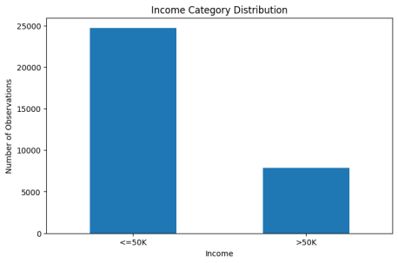  Figure 1: Income category distribution (bar plot)  Interpretation: The data is imbalanced, with far more individuals in the <=50K group. | 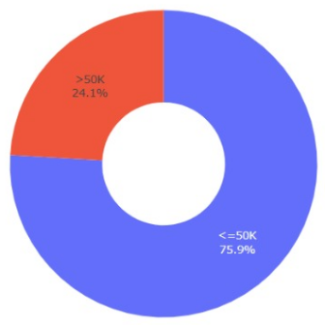  Figure 2: Income category distribution (donut chart, Plotly)  Interpretation: 75.91% earn <=50K and 24.09% earn >50K.
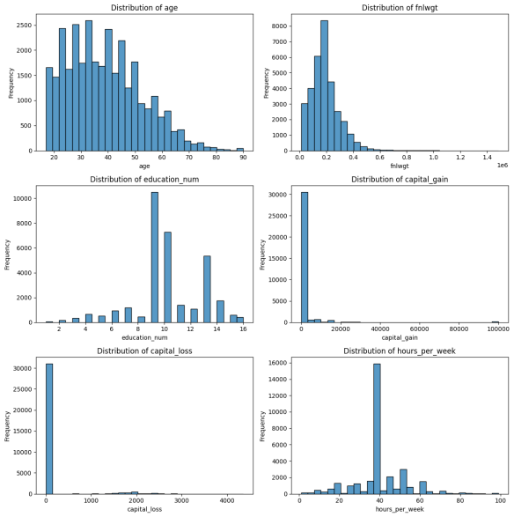  Figure 3: Histograms of numerical variables  Interpretation: Most variables are skewed. capital_gain and capital_loss are concentrated at zero; hours_per_week peaks at 40. | 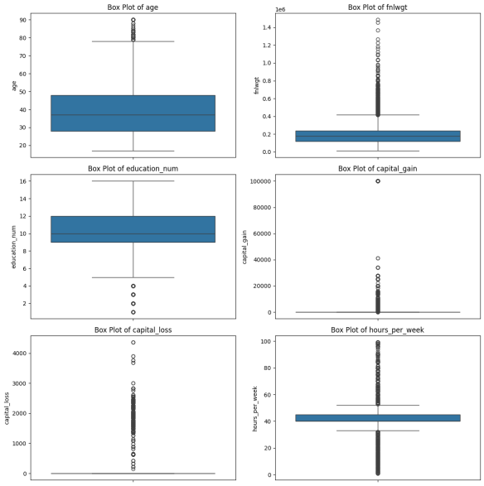  Figure 4: Box plots of numerical variables (plotted separately)  Interpretation: capital_gain, capital_loss, fnlwgt and hours_per_week show many extreme values; age and education_num are more balanced. Each variable is plotted separately because the scales differ.
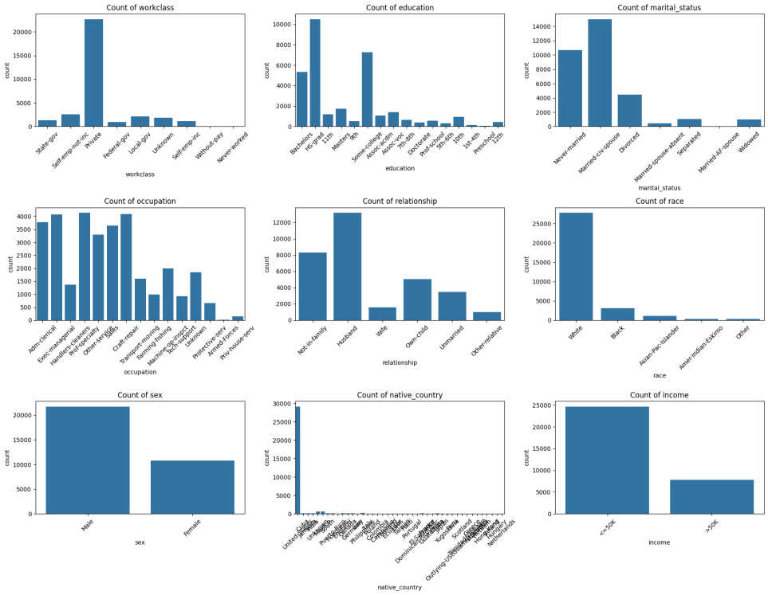
Figure 5: Count plots of categorical variables
Interpretation: Private workclass, Married-civ-spouse and Never-married status, Husband and Not-in-family relationships, White race and Male sex are the largest groups.
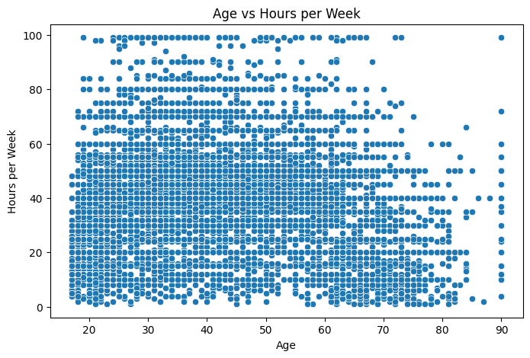  Figure 6: Age vs hours per week (scatter plot)  Interpretation: Points are widely scattered, so there is no strong linear relationship. | 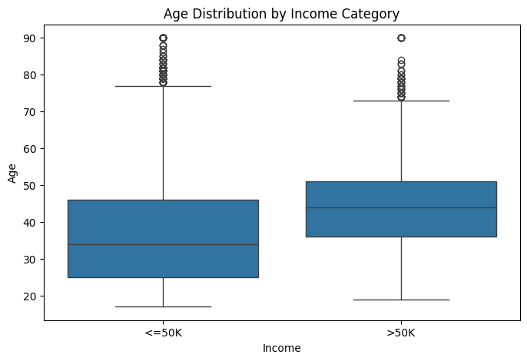  Figure 7: Age distribution by income (box plot)  Interpretation: The >50K group has a higher median age than the <=50K group.
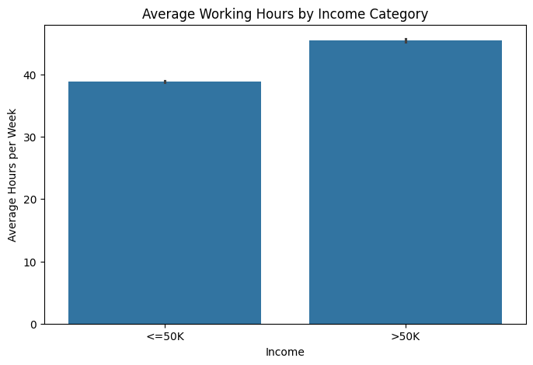  Figure 8: Average working hours by income (bar plot)  Interpretation: The >50K group works slightly more hours per week on average. | 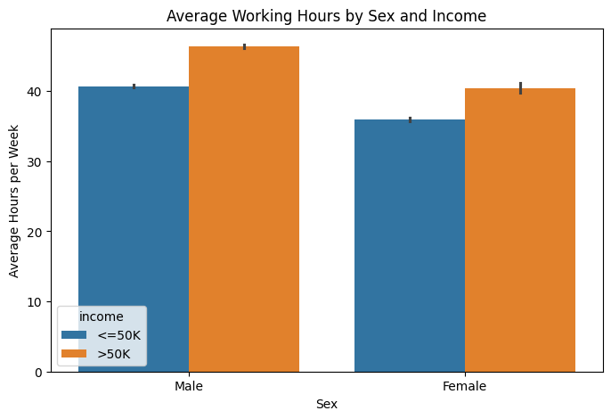  Figure 9: Average hours by sex and income (grouped bar plot)  Interpretation: The >50K group works longer hours for both sexes, with a bigger gap among males.
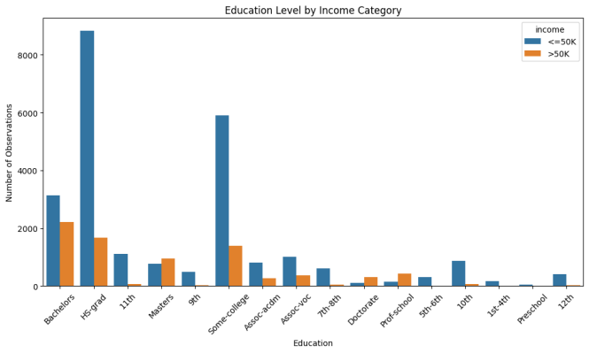  Figure 10: Education level by income (count plot)  Interpretation: Bachelors, Masters, Doctorate and Prof-school have a much larger share in the >50K group. | 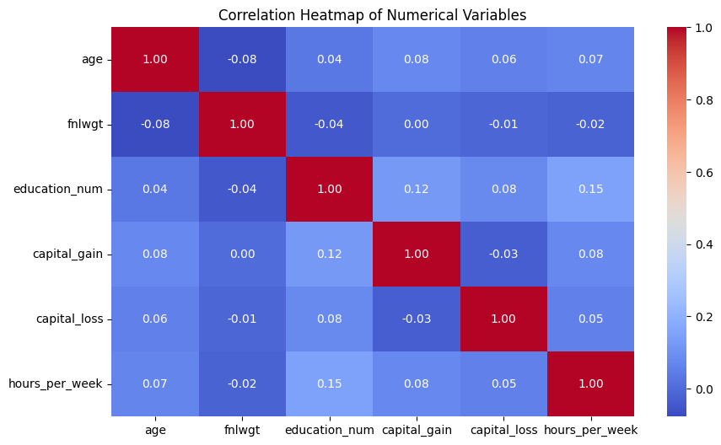  Figure 11: Correlation heatmap of numerical variables  Interpretation: All correlations are weak; the highest is 0.15 between education_num and hours_per_week.
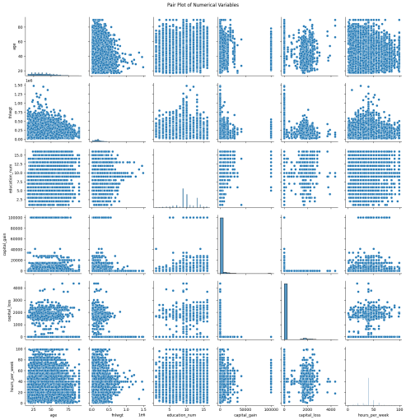
Figure 12: Pair plot of numerical variables
Interpretation: No strong linear relationships are visible; capital_gain and capital_loss cluster around zero.

Graph Summary: Factors Associated with Income
Figure | Variable(s) | Summary | Association with income
1, 2 | Income category | 75.91% earn <=50K and 24.09% earn >50K; the data is imbalanced. | Target variable
3, 4 | Numerical variables | Skewed distributions; capital_gain and capital_loss are mostly zero; many extreme values. | Not a direct factor
5 | Categorical variables | Private sector, Married-civ-spouse, White and Male are the largest groups. | Distribution only
6 | Age and hours per week | Widely scattered; no strong linear relationship. | None between the two
7 | Age | Higher median age in the >50K group. | Yes, moderate
8 | Hours per week | Higher average hours in the >50K group. | Yes, moderate
9 | Education | Bachelors, Masters, Doctorate and Prof-school have a larger share in >50K. | Yes, strongest
10 | Correlations | All correlations are weak (highest 0.15). | Weak
11 | Sex and hours | >50K group works longer hours for both sexes; bigger gap among males. | Yes, differs by sex
12 | Numerical variables | No strong linear relationships. | Weak

Graphs That Affect Income
Figure | Variable | Summary | Effect on income
9 | Education | Bachelors, Masters, Doctorate and Prof-school have a larger share in the >50K group than lower education levels. | Strongest effect: higher education goes with higher income
7 | Age | The >50K group has a higher median age than the <=50K group. | Moderate: older individuals are more often in >50K
8 | Hours per week | The >50K group works more hours per week on average. | Moderate: longer hours go with higher income
11 | Sex and hours | The >50K group works longer hours for both sexes, with a bigger gap among males. | Hours-income link holds for both sexes, larger among males

Education shows the clearest association with income, followed by age and weekly working hours. These are associations, not proof of cause.

10. Key Findings and Insights
- Income distribution: 75.91% earn <=50K and 24.09% earn >50K, so the data is imbalanced.
- Education: higher education (Bachelors, Masters, Doctorate, Prof-school) is more represented in the >50K group.
- Age: the >50K group has a higher median age.
- Working hours: the >50K group works more hours per week on average.
- Sex and income: average working hours differ by sex and income group, with a larger gap among males.
- Correlation: numerical variables are only weakly correlated; education_num and hours_per_week is the strongest pair at about 0.15.
- Data quality: duplicates, "?" values and inconsistent country labels were fixed, and outliers were kept because they may be valid.

11. Conclusion
This project used Python (Pandas, NumPy, Matplotlib and Seaborn) for data cleaning, exploratory analysis, statistical analysis and visualization of the Adult Income dataset. Education level, age and working hours show clear patterns related to income category, with higher education being the most visible. However, these are associations only; the findings do not establish that any single factor directly causes higher income.

12. Limitations and Future Scope

Limitations
- The data comes from the 1994 U.S. Census, so it may not reflect current income patterns.
- The income variable has only two categories and the data is imbalanced (about 76% vs 24%).
- capital_gain and capital_loss are mostly zero and highly skewed; variables with very different scales are better shown separately or on a log scale.
- Outliers were retained, which can affect averages and some plots.
- The analysis is exploratory and shows association, not causation.

Future Scope
- Apply a log transformation to skewed variables and plot large-scale and small-scale variables separately.
- Build and compare classification models (for example logistic regression and decision trees) to predict income, handling class imbalance.
- Use statistical tests such as the chi-square test to confirm relationships.
- Use more recent data and add extra features for deeper analysis.

13. References
- UCI Machine Learning Repository: Adult Dataset. https://archive.ics.uci.edu/dataset/2/adult
- Kohavi, R. (1996). Scaling Up the Accuracy of Naive-Bayes Classifiers: A Decision-Tree Hybrid. Proceedings of the Second International Conference on Knowledge Discovery and Data Mining (KDD-96).
- Pandas documentation. https://pandas.pydata.org/docs/
- NumPy documentation. https://numpy.org/doc/
- Matplotlib documentation. https://matplotlib.org/stable/
- Seaborn documentation. https://seaborn.pydata.org/

